Assignment-18.2: Travel data analysis

1: Find out the top 10 destination people travel the most: Based on the given data, we can find the most popular destination that people travel frequently. There are many destinations out of which we will find only first 20, based on trips booked for particular destinations.

Driver Class:



Mapper Class:



In mapper since top 10 Destination depend on no of people travelling a count of people were made from adult to infants and destination is send as key and count as value

Reducer Class:

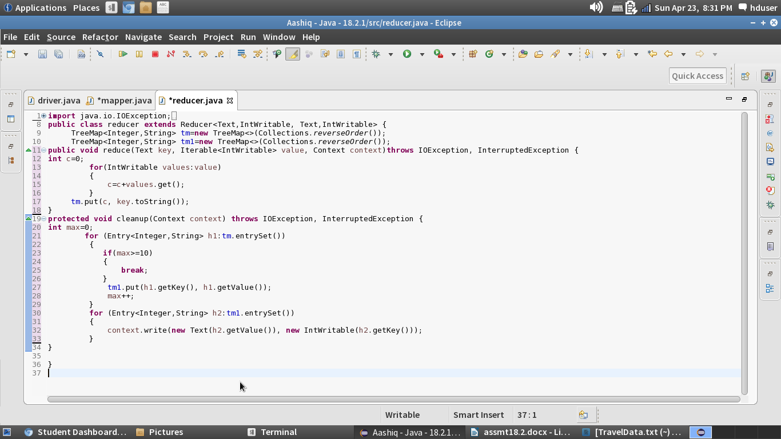

Running the Jar File:

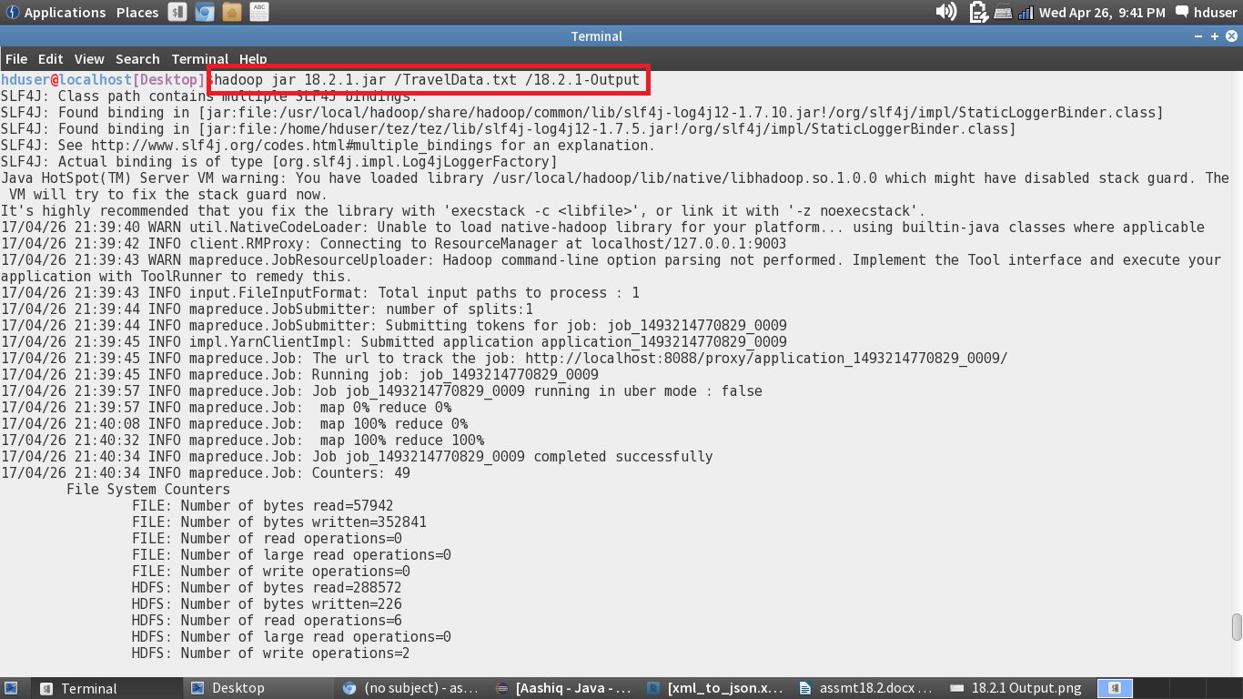

Output:

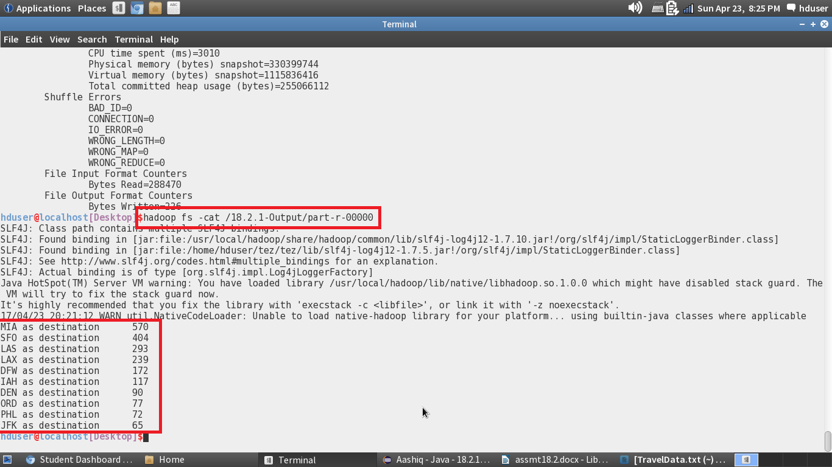

2: Find out the top 10 cities that generate high airline revenues for travel, so that the site can concentrate on offering discount on booking, to those cities to attract more bookings.

Driver Class:

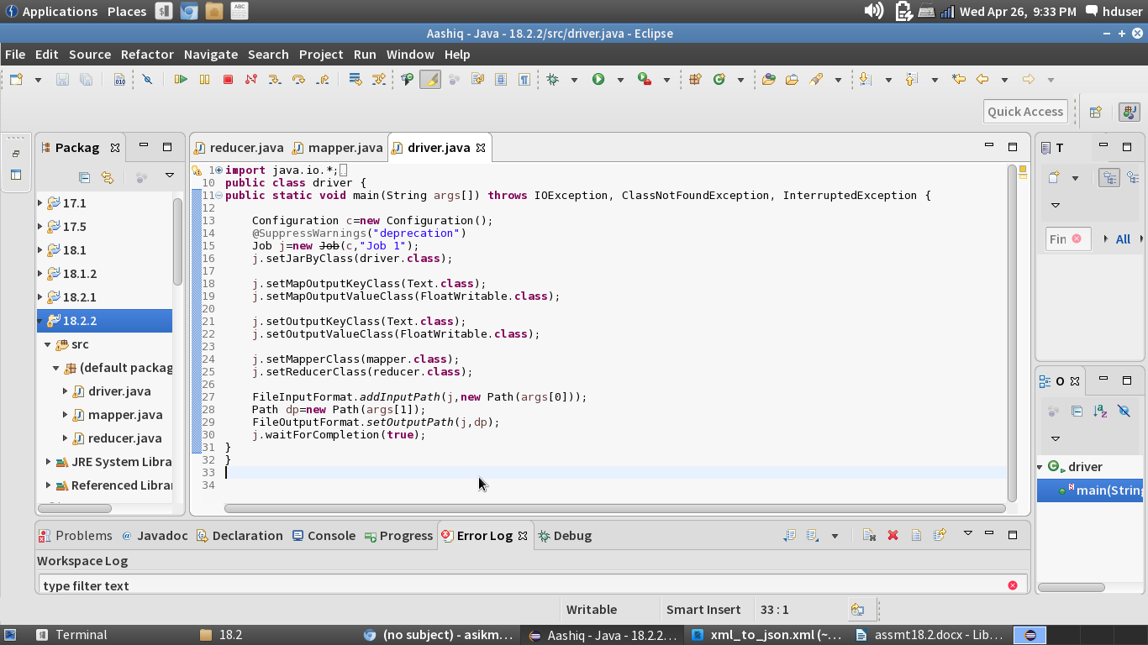

Mapper Class:



Reducer Class:



Running the Jar File:

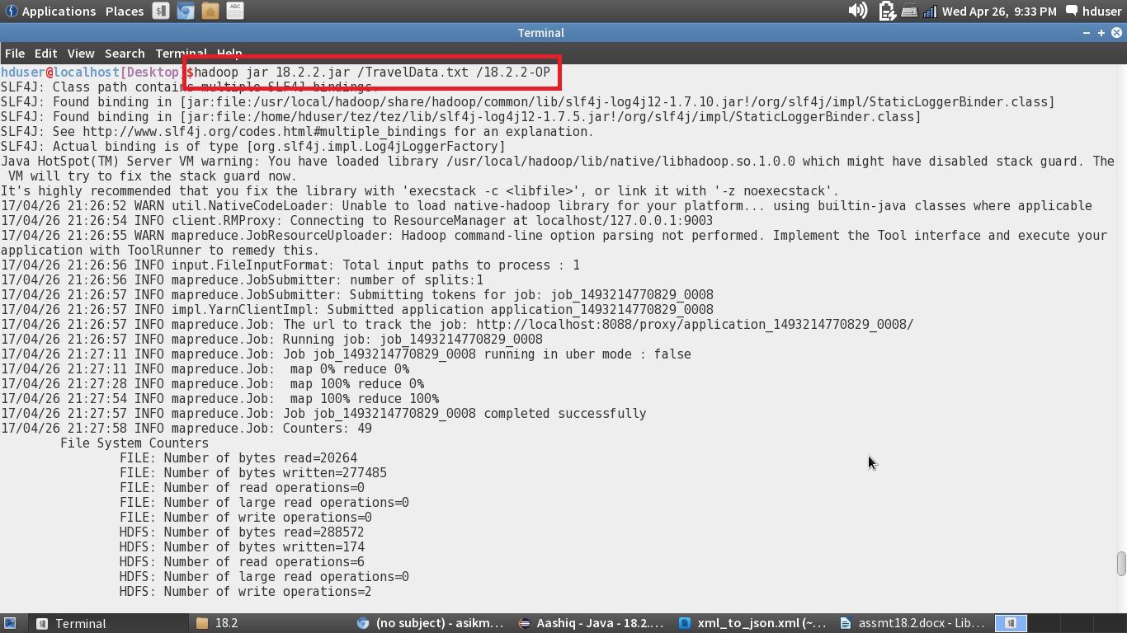

Output:

